NAME: G. Yashmita REG NO: 192511032
(JIRA)
EXPERIMENT 13: KANO
You are tasked with developing an Online Learning Platform. The
platform should include the following functionalities:
1. Course Enrollment and Registration
2. Video Lecture Streaming
3. Interactive Quizzes and Assignments
4. Progress Tracking Dashboard
5. Peer-to-Peer Discussion Forums
6. Certificate Generation
Use Jira to categorize and prioritize these requirements using
Kano techniques.

Aim
The objective of this experiment is to develop an Online Learning Platform project in Jira Software and categorize its requirements using the Kano prioritization techniques to support effective project planning and requirement management.
Software Requirements
Software: Jira Cloud (Web Application)
Web Browser: Google Chrome / Microsoft Edge
Internet Connection: Required

Theory
Requirement prioritization enables development teams to identify the most important features that should be implemented first. The Kano model classifies features as Basic, Performance, or Delighter based on customer expectations. Integrating these techniques in Jira helps teams prioritize tasks, improve sprint planning, and deliver software that meets user needs efficiently.

Procedure

Step 1:
Open a web browser, log in to Jira Software, and create a Scrum Project named Online Learning Platform. Create six project tasks related to the application.
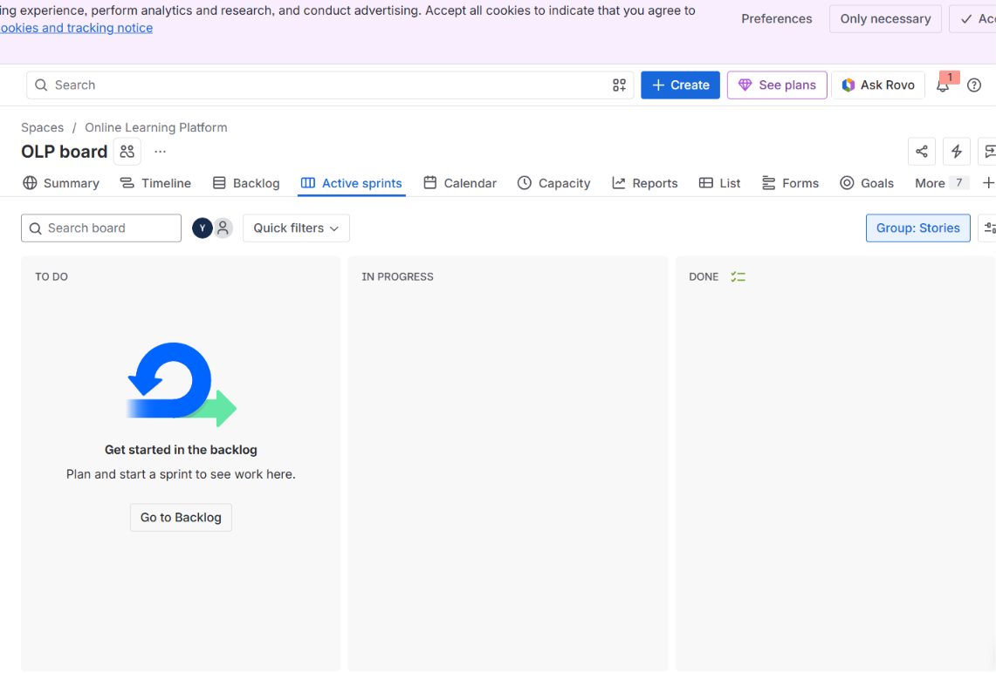
Figure 1. Creating the Scrum Project.

Step 2:
Create a new Sprint and move all the created tasks from the Backlog into the sprint for development.
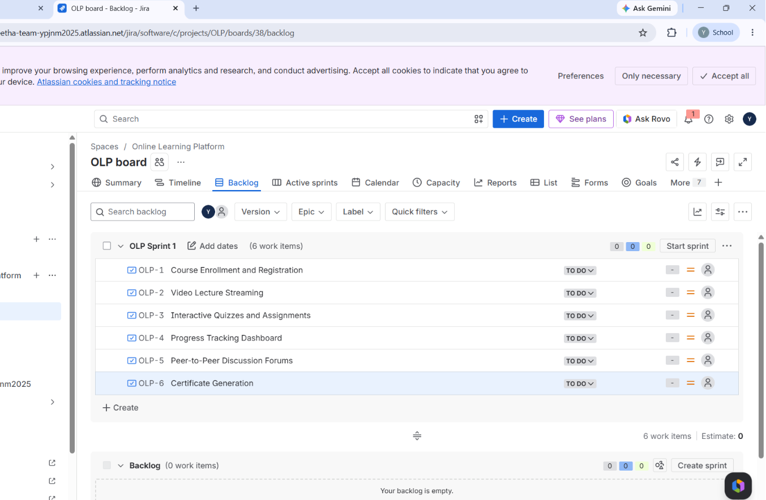
Figure 2. Creating and Planning the Sprint.
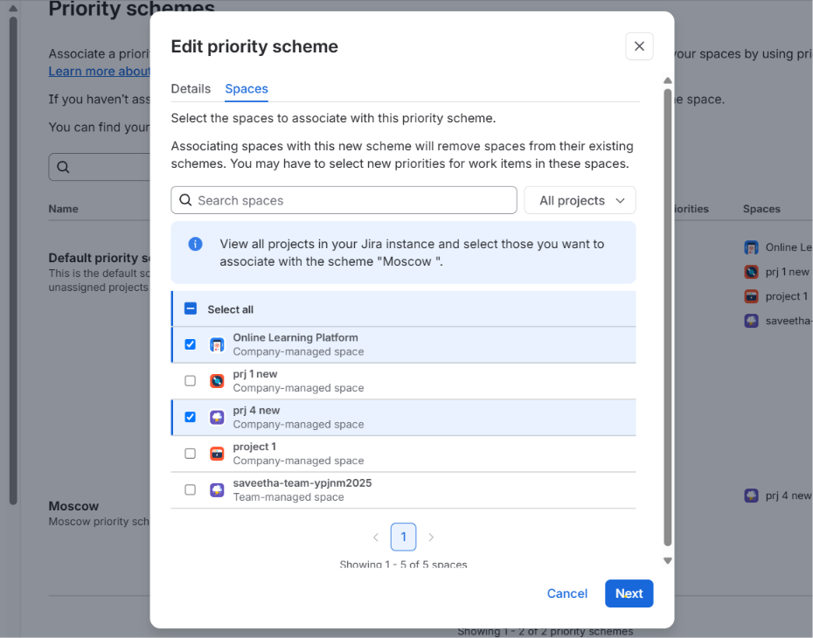

Step 3:
Assign Kano categories to each issue using the following labels:
- Basic
- Performance
- Delighter
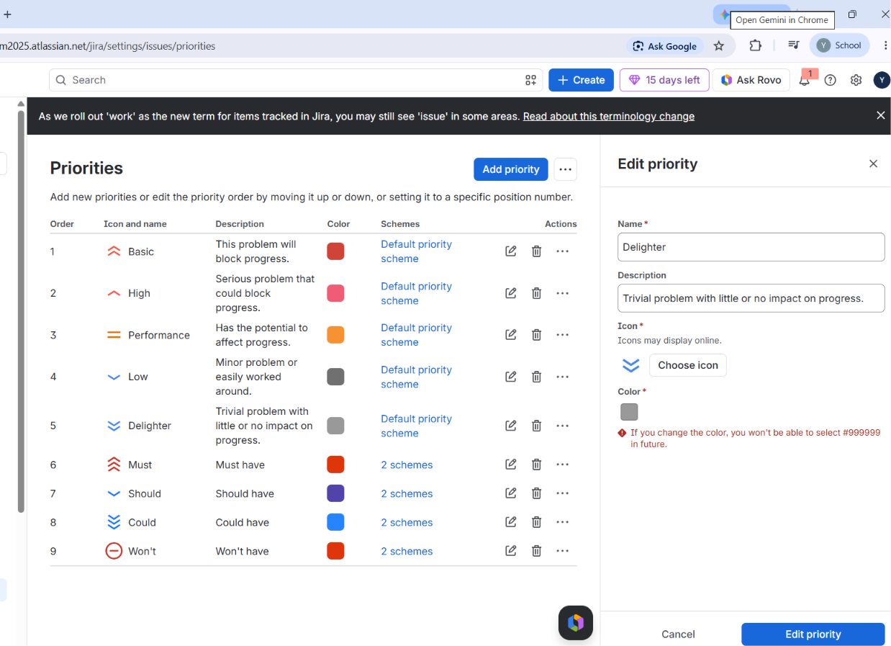

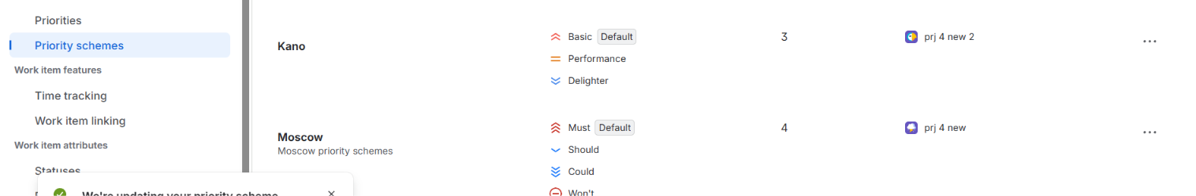
Figure 3. Applying Kano Classifications.

Step 4:
Save all changes and verify that every Jira issue displays the correct Kano labels.
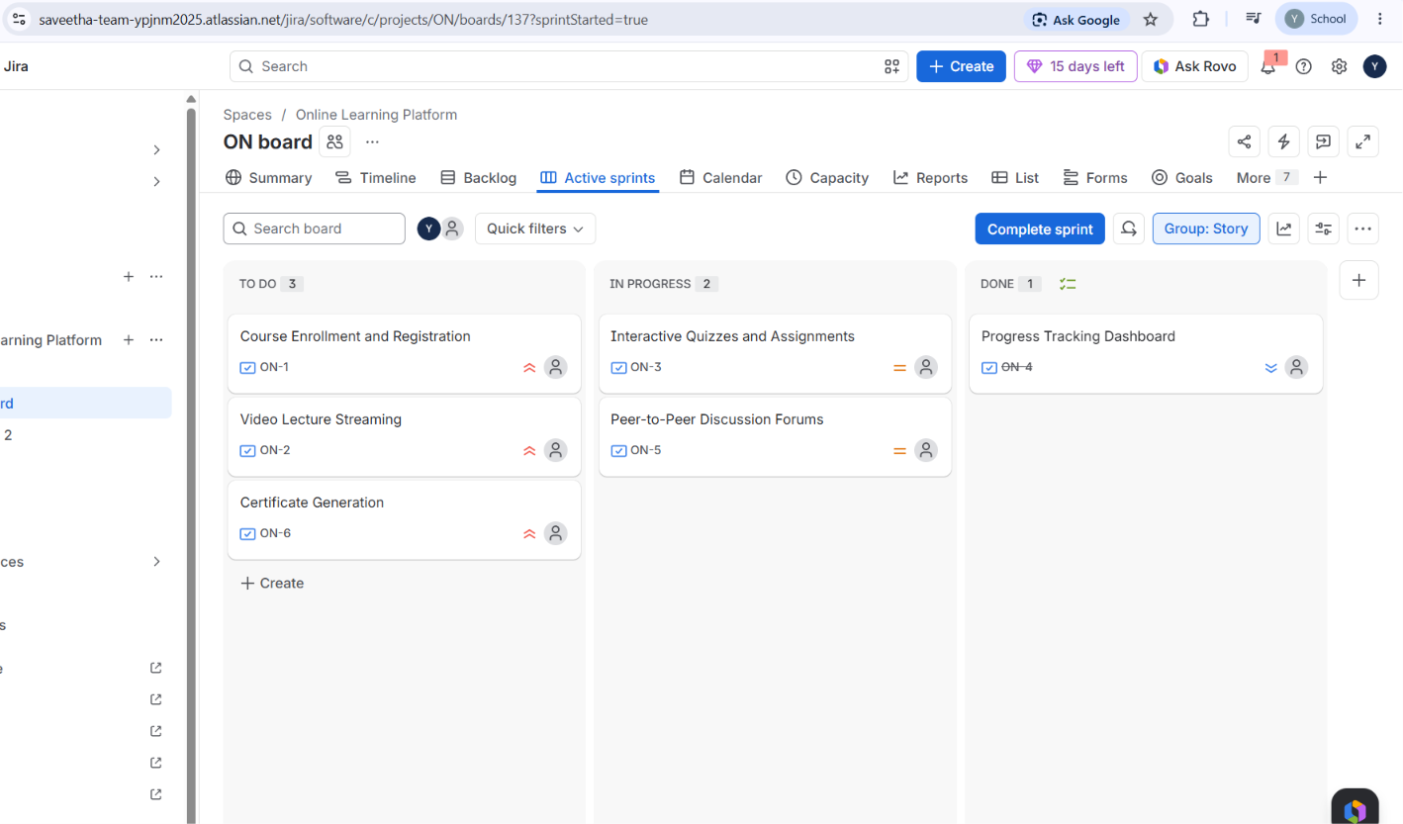

Figure 4. Verifying Requirement Labels.

Result
The Online Learning Platform project was successfully created in Jira Software. The project requirements were categorized using the Kano techniques, demonstrating how feature prioritization supports effective sprint planning, improves requirement management, and helps deliver software that meets both business objectives and user expectations.

